/`

|  |  |  |  |  |  |
| --- | --- | --- | --- | --- | --- |
| **NAME** |  | | | | |
| **SUBJECT** | **TECHNICAL DRAWING 1 & 2** | **CLASS** | **SS2** | **DURATION** | **2 ½ HOURS** |

**INSTRUCTIONS**: This booklet consists of two papers. Answer **paper 1** in your Objective Test answer sheet and **paper 2** in your answer booklet. **Paper 1** will last for **1 hour** after which the answer booklet will be collected. Do **not** start **paper 2** until you are told to do so. **Paper 2** will last for **1 ½ hours**.

**PAPER 1 (1 hour)**

**OBJECTIVES (40 MARKS**

1. Which of the blocks below is drawn obliquely?….

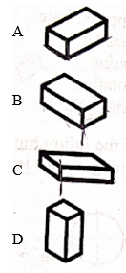

1. The auxiliary view object can be used to determine the following EXCEPT
2. Edge-view of a plane
3. Point-view of a line
4. True size and form of a plane
5. Vanishing point

Use the drawing below to answer questions 3 and 4.

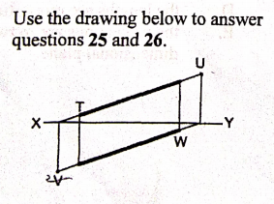

1. Which of the following is horizontal trace?
2. T
3. W
4. U
5. V
6. Which of the following is vertical trace?……
7. T
8. U
9. V
10. W
11. The type of arc drawn below is

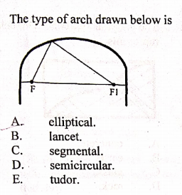

1. Elliptical
2. Lancet
3. Segment
4. Semicircular

Use the drawing below to answer questions 31 and 32.

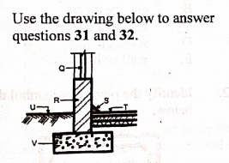

1. Window is represented by letter
2. Q.
3. R
4. T
5. S
6. The part labelled V is
7. Concrete slab
8. lintel
9. foundation footing
10. wall
11. The material symbol shown below is

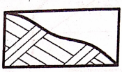

1. concrete
2. rock
3. sand
4. glass
5. Which of the following is shown on the blueprint?
6. Contract fee
7. Contract firm
8. Cost of materialsl
9. Location of project
10. The part of the roof labelled K in the figure below is called.

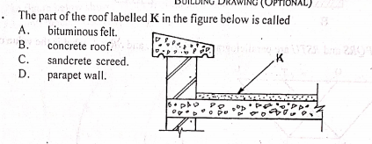

1. Bituminous felt
2. concrete roof
3. sandcrete screed
4. parapet wall
5. The function of internal wall is to
6. Carry weight
7. Divide space
8. Enhance stability
9. Reinforced foundation

The figure below is the frame of a door, use it to answer questions 12 and 13

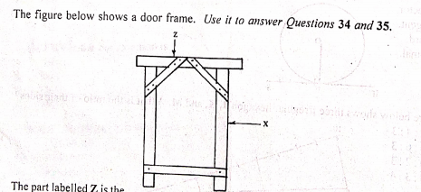

1. The part labelled Z is the
2. brace
3. jamb
4. head
5. horn
6. The part labelled X is
7. Brace
8. Jamb
9. Sill
10. horn
11. A function of lintel is .
12. Improve the appernce of openings
13. Bridge opennings
14. Reduce wall thickness
15. Increase wall length

The figure below shows profile of a stair, use it to answer questions 15 and 16

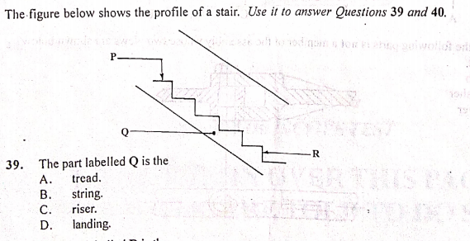

1. The part labeled Q in the figure above is
2. tread
3. string
4. riser
5. landing
6. The part labeled K in figure above is.
7. tread
8. landing
9. nosing
10. riser

use the diagram below to answer questions 17 and 18

A

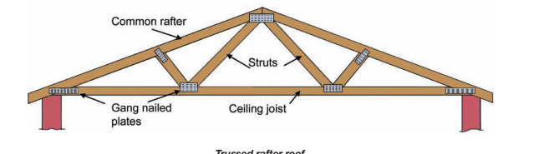

B

1. The part labelled A is called.
2. purlin
3. strut
4. ceiling joist
5. hangeer
6. The type of roof shown below is
7. Double roof
8. Lean to roof
9. Close couple roof
10. trussed roof
11. The following are types of perspective drawing EXCEPT.
12. one point perspective drawing
13. two point perspective drawing
14. three points perspective drawing
15. four points perspective drawing
16. The type of door shows below with its symbol is

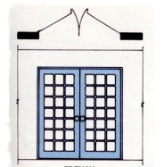

1. Panel door, single swing
2. French door, double swing
3. Roller shutter door
4. English door, single swing
5. The working drawing should possess the following features except that
6. types and cost of materials to be used are indicated
7. title block should be properly placed.
8. all views should be fully dimensioned
9. all views should be clearly drawn.
10. A horizontal column over a space is.
11. column
12. beam
13. pillar
14. brace
15. The type of stair suitable for where space is limited is
16. spiral
17. straight flight
18. bifurcated
19. dog legged
20. 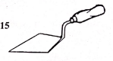The tool shows in the figure below is
21. shovel
22. angle iron
23. trowel
24. spade
25. Which of the following features is not shown on building drawing?
26. Hardcore
27. Concrete
28. Foundation wall
29. Earth filling
30. The figure below shows a part of a section through a roof and wall. The part labeled S is.

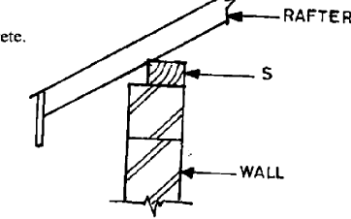

1. facial board
2. reinforcement
3. wall plate
4. lintel

Use the diagram below to answer questions 32 and 33

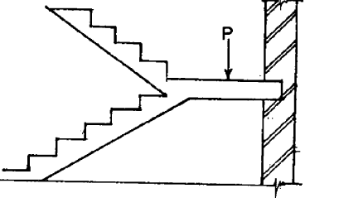

1. The part labeled P is ………
2. going
3. landing
4. flight
5. thread
6. How many flights are in the staircase?
7. One
8. Two
9. Three
10. Four
11. Which of the following is not a type of door?
12. Battern
13. Raft
14. Brazen
15. Ledged
16. A site plan shows
17. Elevation of the building
18. Location of the building
19. Foundation of the building
20. Cross section of the building
21. What type of foundation is sown in the figure below?

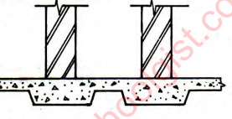

1. strip foundation
2. raft foundation
3. piled foundation
4. pad foundation
5. The following are types of floor EXCEPT.
6. cotton floor
7. tiled floor
8. suspended floor
9. cement screed
10. Which of the following is pitched at one side only?
11. Hipped roof
12. Shed roof
13. Butterfly roof
14. Gabble roof
15. The primary function of the external walls of a building is to.
16. carry load
17. divide space
18. reinforced building
19. reinforced foundation
20. Which of the building parts listed below is found on a window.
21. jamb
22. eave
23. pile
24. tread
25. Which of the following is not a type of roof?
26. Eaves
27. Hipped
28. Lean-to
29. Butterfly
30. 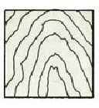The symbol shown below represent ……..
31. wall
32. ground
33. wood
34. tiles
35. 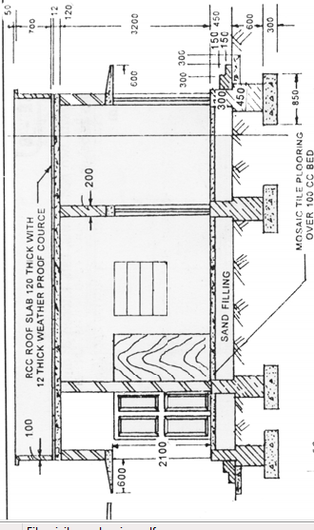The drawing shows below is a ……
36. floor plan
37. building section
38. mechanical section
39. structural details drawing
40. Which of the symbol below represent a switch?

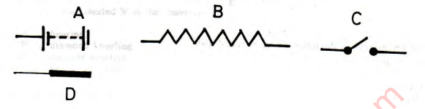

1. In which of the floor construction is wall plate used?
2. Solid concrete floor
3. Reinforced floor
4. Hollow timber floor
5. Pre cast floor

PAPER 2 1 ½ hours

(60 marks)

Answer only ONE question from this paper

All dimension are in millimeters EXCEPT otherwise stated.

1. The sketch below shows the plan of a bungalow. Study the give specifications and answer the question that follows:

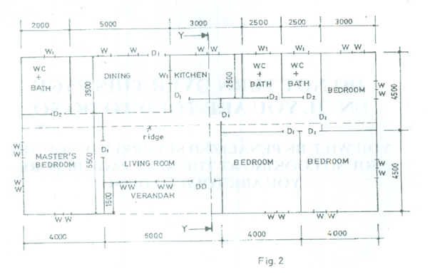

SPECIFICATIONS

All dimensions are given in millimetres.

FOUNDATION: 225 x 675 concrete strip foundation laid over 100 blinding at a depth of 900 below ground level.

FLOOR: 150 hardcore, 150 concrete slab, 25 mortar screed, finish floor level to ceiling 3150.

WALLS: All walls 225.

LINTELS: 225 X 225 reinforced concrete.

DOORS: All doors 2100 x 900 x 40 flush wooden in 100 x 50 timber frame except at verandah with glazed double door, 2100 x 1500 x 40 in aluminium frame.

WINDOWS: Sliding glass in aluminium frames, bath W.C. and store windows 600 x 600, others 900 x 1200.

BEAM: 225 x 225 reinforced concrete, 2400 above floor level.

COLUMN: 225 X 225 reinforced concrete.

ROOF: 25o double pitch with eaves 600 and corrugated asbestos sheets, timber rafter 1000 x 50 at 1000 centres, fascial board 25 x 250.

(Assume unspecified dimension)

a. Draw to a scale of 1:100 the:

i. Floor plan;

ii. Front Elevation;

b. Draw to a scale of 1:50, the sectional view on plane Y–Y.

Technical Drawing 3, WASSCE (PC 2ND), 2019, Q4

1. Building Drawing Study the sketch plan of a three bedroom bungalow below and the given specifications to answer the questions that follow

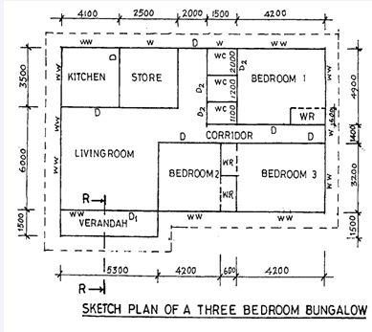

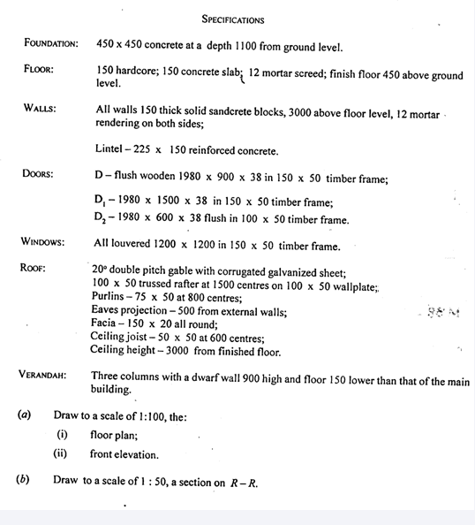

Technical Drawing Paper 2, Nov/Dec. 2011, section B, 1